Implementation: Post-Feedback Process (Project Spotlight Pilot)

I. Procedure Implemented:
Concept for the post-feedback procedure: the channel #postfeedback is in the HAAG Slack channel.
- To receive feedback about a Project Spotlight draft or faces of HAAG draft, leave a draft of the document in the #post-feedback channel.

- Every draft will be in a single folder that contains the draft itself along with any feedback that is relevant to it.

- There will be an announcement format that will be implemented to act as a notification for the new draft to be reviewed and analyzed.

- There will be a protocol of having 48 hours to receive feedback about the draft. This protocol will help maintain and retain the cycle of review and feedback proceeding.

II. Context and Participants:
- Executed inside the content stream of the project spotlight for HAAG. This is also part of a broader content pipeline for LinkedIn.

- For the implementation, we tested out the procedure by writing out a draft of a project spotlight called “Predicting Railroad Crossing Delays with Machine Learning”.

- The researchers who are part of this project were Leonardo Savasta, Xu Che, and Isaac A. Felix. The participants of the implementation for this test procedure were Sheena and Neelima. Neelima provided the source material and documents that needed to be edited. While Sheena wrote out, edited, and revised the draft of the post.

III. Implementation Approach:
- Sheena wrote out the draft for the Project Spotlight post.
- The team head, Neelima, provided the source material and Word documents along with her edits for the draft.

- Sheena reviewed, analyzed, and made edits to Neelima’s Word document. After that, she rewrote the post for the Project Spotlight.

- The draft is posted in the #Postfeedback Slack channel; however, no feedback was received or provided throughout this experimentation.

- The entire team, composed of Sheena, Neelima, and Jacob, had detailed discussions on how to improve the process of receiving feedback on a post draft. This led to creating the current idea of having a procedure where the draft gets posted in the #post-feedback Slack channel. There will be one folder created and assigned to each draft. There will also be an implementation of making sure there is a consistent way of announcing when drafts get posted into the Slack channel, along with providing a 48-hour period to allow for enough time for proper feedback response.

IV. Outcomes and Evidence:
- A draft of the project spotlight was fully written out, and it was finalized once Sheena incorporated the edits that Neelima made.

- When attempting to get feedback for the project spotlight post draft, there were no responses. By having no responses for the draft, this shows that there was a problem that needed to be resolved and addressed.

- We revised the procedure of the implementation cycle by making sure the draft gets posted onto the #feedback Slack channel, creating an announcement format, and providing a 48-hour window for receiving feedback on the draft post.

V. Effectiveness:
- The collaboration with Neelima on the project spotlight test experiment worked successfully through the creation of a draft that was finalized and is ready to be posted on LinkedIn.

- Receiving feedback on a draft presented was challenging and not successful because there were no clear guidelines and protocols for receiving feedback on a draft post.

- The improvements to the post feedback structure properly handle the issue between receiving feedback, making protocols on how drafts get announced, and setting a clear deadline on when and how to receive feedback on the post draft.

- Overall, the effectiveness of the improved version has not been validated and needs to be assessed during the next post draft cycle.

VI. Challenges and Limitations:
- The primary feedback request on the post draft did not receive any responses at all. The main issue was that there was no formal announcement being made, no clear deadline to respond to the post. This was an issue only detected in hindsight.

- The most recent and revised procedure has not been tested from start to finish. This makes determining the overall effectiveness of this procedure unauthenticated.

- Also, written documentation about the announcement format that was applied had not been wholly completed at the time of this report.

VII. Next Steps:
- Plans to implement the next drafts of the project spotlight or faces of HAAG stream contents across a fully revised procedure, and test whether the drafts get feedback within 48 hours.

- Conclude the criteria of the announcement protocol for new post drafts in the #post-feedback channel of Slack.

- Plan to review and assess if the 48-hour response period matches and works well with the organization's real response trends.

VIII. Contributors:
- Sheena - wrote, edited, and revised the project spotlight post along with redesigning the feedback procedure.

- Neelima (Team Leader) - provided material, made edits, gave feedback, and instructions on the task overall

- Jacob- reviewed the document and provided verbal feedback

VIII. Proof of Work
Below is the implementation procedure of the project spotlight draft that the team worked on.

Predicting Railroad Crossing Delays with Machine Learning

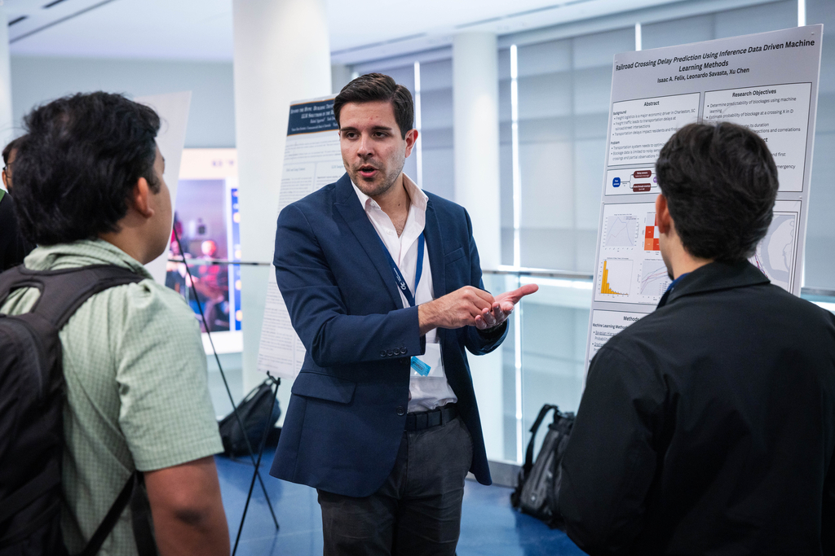

The HOOK:
The fact that people wait at railway crossings has an impact on public transit, commuters, and emergency services; in busy shipping cities like Charleston in South Carolina and Savannah in Georgia, the ability to predict these delays can contribute to a safer and more efficient transportation system.
Isaac A. Felix, Leonardo Savasta, and Xu Che, all of whom are researchers at the Georgia Institute of Technology, are studying how machine learning can be used in order to predict blockages at railroad crossings even when the transportation data is limited or noisy.
The Challenge:
Getting reliable data on traffic bottlenecks is difficult since the information is generally obtained from sensors ,which never have complete accuracy ,or from incomplete reports regarding bus operations. The team hopes to find out whether machine learning can still produce useful predictions in such real-world circumstances.

The Methods:
To address the challenge of predicting railroad crossing delays with noisy and incomplete data, the project will use several analytical and machine learning methods:
- The Bayesian Hierarchical Model will use the bus inference data to estimate the probability that a railroad crossing will be blocked and to predict how long the blockage is expected to last. It takes into account the uncertainty and variability that are inherent in the indirect observations of buses, which allows it to produce reliable predictions even when the data is incomplete.
- The Gradient Boosting Model will use the TrainFo sensor data from railroad crossings in order to predict both the probability and the duration of blockages, and it is able to capture the complex, nonlinear relationships between the sensor measurements and the crossing delays.
- Spatial and Statistical Analysis: The study makes use of GIS visualization, carries out correlation analysis regarding sources and crossings, and applies statistical significance testing in order to gain a better understanding of how blockage interactions occur throughout Charleston's transportation network. Further insights were obtained into freight-caused traffic delays and the factors that influence railroad crossing blockages through exploratory analysis of the distributions of blockage durations and temporal trends.
The use of spatial analysis together with predictive modeling will not only allow for accurate predictions of delays but also lead to a more detailed understanding of how congestion at railroad crossings spreads throughout Charleston's transportation network.
The Results:
The analysis uncovered several important insights:
- The sensor data from TrainFo is available at only a few railroad crossings.
- At some of the crossings the sensor readings are so noisy that a reliable analysis cannot be carried out.
- The information obtained from bus inference data does have value, but it is affected by the bus routes and by the surrounding traffic.
Looking Ahead:

In future research, the focus will be on comparing camera data with sensor observations to detect noise, using GPS and bus data to separate the signal from the noise, looking into further hierarchical modeling techniques, and improving the predictions as to both the duration and the probability of blockages.

To sum up, the secret to more intelligent transportation is more intelligent data; this project promotes the development of transportation networks that are safer, more resilient, and more efficient by integrating transportation science, spatial analytics, and machine learning.

The Tags:

#HAAG#OMSCS#OMSA#GeorgiaTech#Research#Machine Learning#AI etc

